Assignment 2 – Case Study Lab

Stage 2 Lab Activities

SmartCare Requirements Engineering
AI OFF -> AI ON -> VERIFY | 1 hour

Learning objectives
- Analyse the SmartCare client brief.
- Identify stakeholders and scope.
- Write functional and non-functional requirements.
- Develop user stories and Given-When-Then acceptance criteria.
- Use AI to critique requirements without allowing it to invent stakeholder needs.
- Produce SmartCare Requirements Specification v1.0.

Part A - Client Brief: AI OFF
SmartCare uses spreadsheets and paper records. Staff report duplicate bookings, difficulty finding patient information, inconsistent appointment status and limited appointment history. Management wants a small, maintainable patient, practitioner and appointment system.

Part B - Stakeholders and Scope: AI OFF
Identify at least four stakeholders. Create In Scope and Out of Scope lists. Label uncertain features as provisional rather than confirmed.
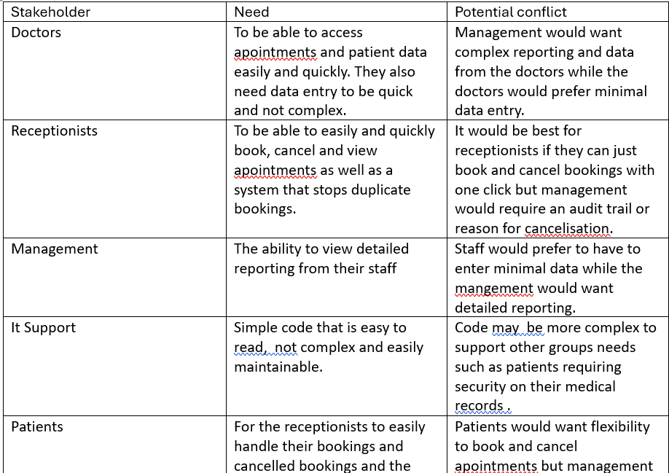

Feature | Scope | Status | Source/Reason
Appointment management (book and view) | In Scope | Confirmed | Client asked for software to manage patients, practitioners and appointments
Patient search | In Scope | Confirmed | Brief lists difficulty locating patient records
Staff can cancel appointments | In Scope | Confirmed | Brief lists manual cancellation processes; your Stage 2 functional requirement
Cancelled appointments remain in history | In Scope | Confirmed | Brief lists lack of reliable appointment history
Prevent duplicate bookings | In Scope | Confirmed | Brief lists duplicate bookings; your receptionist need
Practitioner schedule view | In Scope | Provisional | Brief says visibility of availability is limited but not whose; your "assumption requiring validation"
Receptionists create appointments | In Scope | Provisional | Brief never names the receptionist role; your "assumption requiring validation"
Audit trail / reason for cancellation | In Scope | Provisional | Management need from stakeholder map; not in the brief
Detailed reporting | In Scope | Provisional | Brief mentions only basic operational reports; management wants more detail
Fast, minimal data entry | In Scope | Provisional | Doctors' need; "fast" isn't measurable yet
Secure patient records | In Scope | Provisional | the brief doesn't mention security
Simple, maintainable code | In Scope | Provisional | IT Support need
Facial recognition login | Out of scope | n/a | Too complex for a simple small-clinic system
AI diagnosis / treatment recommendations / treatment plans | Out of scope | n/a | Clinical, not administrative; liability concerns
Insurance processing | Out of scope | n/a | Not in the brief
SMS reminders | Out of scope | n/a | Nothing in the brief about patient notifications
Online payment | Out of scope | n/a | Not in the brief

Part C - Functional Requirements: AI OFF
Write 8-12 numbered functional requirements using FR-01, FR-02 and so on. Each should describe one observable capability.
Fr-01 = The system shall allow staff to register a new patient record.
Fr-02 = The system shall allow staff to search for a patient by patient ID.
Fr-03 = The system shall allow staff to create an appointment by recording a patient, a practitioner and an appointment time.
Fr-04 = The system shall reject a new appointment if the patient, practitioner or time is missing.
Fr-05 =The system shall reject a booking when the practitioner already has an appointment at the requested time.
Fr-06 = The system shall allow staff to view all appointments.
Fr-07 = The system shall display the current status of each appointment.
Fr-08 = The system shall allow staff to cancel an appointment.
Fr-09 = The system shall retain a cancelled appointment in the appointment history rather than deleting it.
Fr-10 = The system shall allow staff to view the appointments and available times for a given practitioner. (Provisional)
Fr-11 = The system shall produce a basic report showing the number of appointments by status. (provisional.)

Part D - Non-Functional Requirements: AI OFF
Write 4-6 numbered non-functional requirements covering appropriate qualities such as reliability, maintainability, usability, data integrity or testability.
Nfr-01 = The system shall never store two active appointments for the same practitioner at the same time, and every appointment shall refer to an existing patient and practitioner.
Nfr-02 = Patient and appointment data shall still be present after the system is closed and restarted.
Nfr-03 = Booking and cancellation rules shall be kept separate from display and storage code, so a change to one does not require changes to the others.
Nfr-04 = Core business logic shall be testable without the user interface, and every functional requirement shall have at least one test.
Nfr-05 = A receptionist with no prior training shall be able to book an appointment in no more than 5 user actions. (Provisional)
Nfr-06 = Patient search and appointment display shall return results within 2 seconds for the course-scale dataset. (Provisional)

Part E - User Stories and Acceptance Criteria: AI OFF
Write 4-6 user stories. For at least three, create Given-When-Then acceptance criteria including one negative or failure scenario.
Us-01 = As a receptionist, I want to book an appointment by entering a patient, a practitioner and a time so that the visit is recorded without using spreadsheets or paper.
Given Dr Ridley does not already have an appointment booked on 2024-07-20 at 2pm, When a receptionist tries to book an appointment with Dr Ridley on 2024-07-20 at 2pm, Then the system books the appointment and saves it into the database.
Us-02 = As a receptionist, I want the system to stop me booking a practitioner who is already booked at that time, so that duplicate bookings no longer happen.
Given Dr Ridley already has an appointment booked on 2024-07-20 at 2pm, When a receptionist tries to book a second appointment with Dr Ridley on 2024-07-20 at 2pm, Then the system rejects the booking and shows an error message saying that dr Ridley is already booked at that time and only the original appointment is stored.
Us-03 = As a receptionist, I want to cancel an appointment quickly while the record stays in the history so that cancellations are easy but the clinic still has a reliable record of what happened.
Given an appointment for a patient with Dr Ridley exists When the receptionist cancels the appointment Then its status changes to cancelled. It still appears in appointment history but now Dr Ridley can be booked again.
Us-04 = As a receptionist, I want to search for a patient by ID, so that I can find their record quickly instead of looking through paper files.
Given patient id p001 belongs to Jane Doe When the receptionist searches p001 Then Jane Doe's record is displayed.
Us-05 = As a receptionist, I want to know if I type in a patient id that does not belong to a patient.
Given patient id p011 belongs to no one When the receptionist searches p011 Then patient not found is displayed.

Part F - AI Requirements Review: AI ON
Prompt: Act as a software requirements reviewer. Review the SmartCare requirements for ambiguity, inconsistency, missing clarification questions and testability. Do NOT invent new client requirements. For every suggestion, state whether it is based on evidence or is only a question/assumption requiring validation.
Can be found in Ai_usage_stage2

Part G - VERIFY the AI Review
Classify each significant AI suggestion as Accepted, Modified, Rejected, or Unverified. Explain the evidence used.

Suggestion | Accepted, Modified, Rejected, or Unverified | Why?
Cancellation should require a reason | Accepted | Explicitly stated by the client to want an audit trail.
Search by ID only may not solve locating records | Accepted | The receptionist or whoever is looking for records may only know the patient's name and not the id.
Appointment statuses undefined | Modified | Copilot is right appointment status wasn't defined. Copilot used examples for appointment statuses which are booked, cancelled, completed, no-show. I would use cancelled and booked but other statuses being added would be up to the client.
Time granularity and duration undefined | Unverified | It doesn't say anywhere in the brief how long appointments last which is important to stop double bookings.
“Cancel quickly" undefined; NFR-05 covers only booking | Modified | Copilot is right that "quickly" has no measurable meaning, but the brief never mentions speed (it came from my own receptionist's need), so I would extend NFR-05 to cancellation and keep it provisional.
"Active" appointment undefined | Modified | NFR-01 and FR-05 never define "active", but my own US-03 shows a cancelled appointment frees the slot, so I would add that definition to NFR-01 in v1.0.
"Missing" in FR-04 ambiguous | Accepted | FR-04 doesn't say whether "missing" means an empty field or no value at all, and my Stage 1 Part F test only confirmed that a blank patient name is rejected, so I would define "missing" in the spec.
"Available times" undefined | Unverified | The brief mentions "limited visibility of practitioner availability" without saying whose visibility or what availability means, so only the client can answer it and FR-10 stays Provisional.
"Basic report" undefined | Unverified | The brief says "basic operational reports" without defining them, and FR-11 was my own guess, so which reports are needed is a question for the client and FR-11 stays Provisional.

Part H - Finalise SmartCare v0.2
Submit stakeholder analysis, scope, 8-12 FRs, 4-6 NFRs, 4-6 user stories, acceptance criteria, assumptions/open questions and selected AI review evidence.

Reflection
In 150-250 words: What did AI notice that you missed? What did AI invent or overreach on? Which requirement changed after review? Why must requirements have evidence?
After writing out the requirements one thing Copilot noticed that I didn't was that only allowing searching for patient records with patient id is not accounting for patients who don't know their patient id. Using patient id came from my own tutorial work and was not explicitly in the brief. Searching for patient records by their name is a more efficient way than id than is better in line with the brief. Copilot also overreached on numerous things such as when it labelled cancel quickly as evidence based when the brief never explicitly mentions speed or when it wanted to have appointment status for completed and no show when only booked and cancelled were required to fall in line with the briefs requirement of allowing easy cancelisations... After reviewing ai Nfr-05 changed as I extended it to cancellation. Requirements require evidence because requirements validity come from the brief not from how reasonable it sounds.

